Assuming you have python already installed, you’ll also need to install two packages(scrapy and pillow)

You can install them from command line using the command: pip install scrapy pillow

**How to run the spider**

* Navigate to the folder where you have the scrapy.cfg file is contained and open your terminal in that directory, see image below

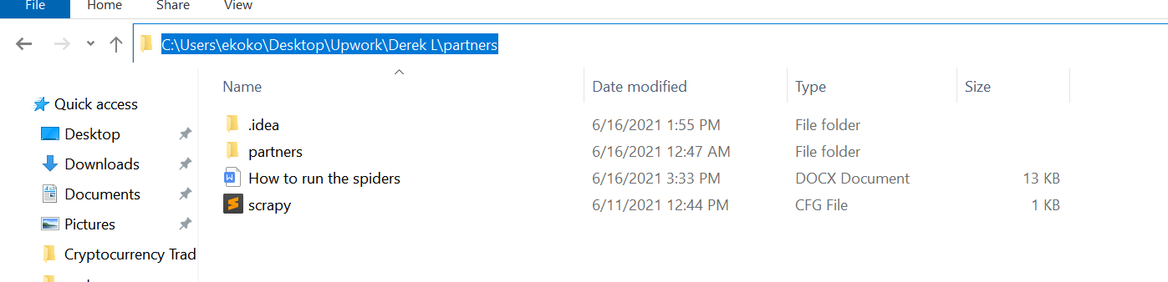

* In the terminal, Type in this command, ‘scrapy crawl spider_name’. For example, to run the jenwoodhouse spider, you would use the command ‘scrapy crawl jenwoodhouse’.

All spiders can be found in the spiders folder, see image below.

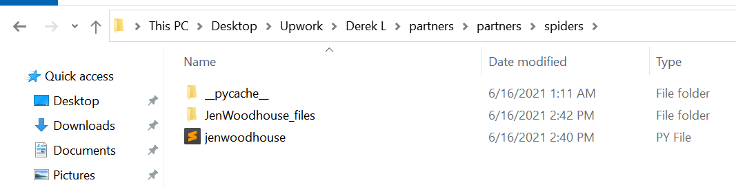

* You would get a prompt to select if you want to scrape all the images or just fetch the json/csv file (fetching both images and scraped data is not best practice).
* Select the one of options and hit enter and wait for the scrape to be completed.
* You will then find a folder named after the website where the images and/or scraped files will be stored.

Note: Ignore any errors/warnings while scraping for images.